University of Michigan Hospital and Health Center Release of Information Unit
Dept. Release of Information Unit - NCAC
2901 Hubbard Street Room 2722
Ann Arbor, MI 48109-0000

Axiom Requisition Copy Service
2869 Jolly Road, Okemos, Michigan 48864
517.886.5099 – 877.886.5090 toll free – 517.886.4116 facsimile – records@axiomcopy.com

REQUEST FOR RECORDS - ORDER NUMBER 01-29018-002

TO THE CUSTODIAN OF RECORDS Date Sent: November 8, 2026
University of Michigan Hospital and Health Center Release of Information Unit
Dept. Release of Information Unit - NCAC
2901 Hubbard Street Room 2722
Ann Arbor, MI 48109-0000
Please find enclosed a request for records of:
Batman
DOB 01/01/1979 SSN xxx-xx-5555
We are requesting the following:

FROM 01/01/1979 TO PRESENT: Any and all MEDICAL RECORDS, including but not limited to patient history form(s), reports, etc. pertaining to Batman SSN: xxx-xx-5555, DOB: 01/01/1979.

INSTRUCTIONS
- FORWARD INVOICE WITH RECORDS – If fee is greater than $50.00 Pre-approval is required.
- PLEASE DO NOT STAPLE DOCUMENTS.
- Mail, email or fax the records to: Axiom Requisition Copy Service (as agent of John Doe, Smith and Jones PC), 2869 Jolly Road, Okemos, MI 48864 – Phone: 517.886.5099 – Fax: (517) 886-4116 – Email: records@axiomcopy.com.
SIGN AND RETURN THIS FORM WITH THE REQUESTED RECORDS
__________________________________________________________
CERTIFICATION OF RECORD SUBMISSION
I certify in response to the request issued to me, that I have submitted a true and complete copy of all requested documents in my control or possession relating to the above person; and that (A) The record was made at or near the time of the occurrence of the matters set forth by, or from information transmitted by, a person with knowledge of those matters; (B) The record was kept in the course of the regularly conducted business activity; and (C) It was the regular practice of the business activity to make the record.

_____________________________________________ _____________________
Signature of the custodian of records Date

If you are sending only part of the documents requested above and some are not in your possession, please check the appropriate boxes below:
- No Medical Records ◻ No X-Ray Films ◻ No Photographs ◻ No Billing Records
If you do not have any of the records requested, please contact our office for an affidavit of no records or send us a letter on your letterhead stating you do not have any of the records requested.

ORDER NUMBER 01-29018-002
University of Michigan Hospital and Health Center Release of Information Unit
2901 Hubbard Street Room 2722
Ann Arbor, MI 48109-0000

X

FROM 01/01/1979 TO PRESENT: Any and all MEDICAL RECORDS, including but not limited to patient history form(s), reports, etc. pertaining to Batman SSN: xxx-xx-5555, DOB: 01/01/1979.

Axiom Requisition Copy Service
2869 Jolly Road
Okemos, MI 48864
Jack Zuk
Axiom Requisition Copy Service
2869 Jolly Rd
Okemos, MI 48864-____
(517) 886-5099
John Doe
Smith and Jones PC
123 East Main Street
Anywhere, MI 12345
(123) 456-7890
Order No. 01-29018-002
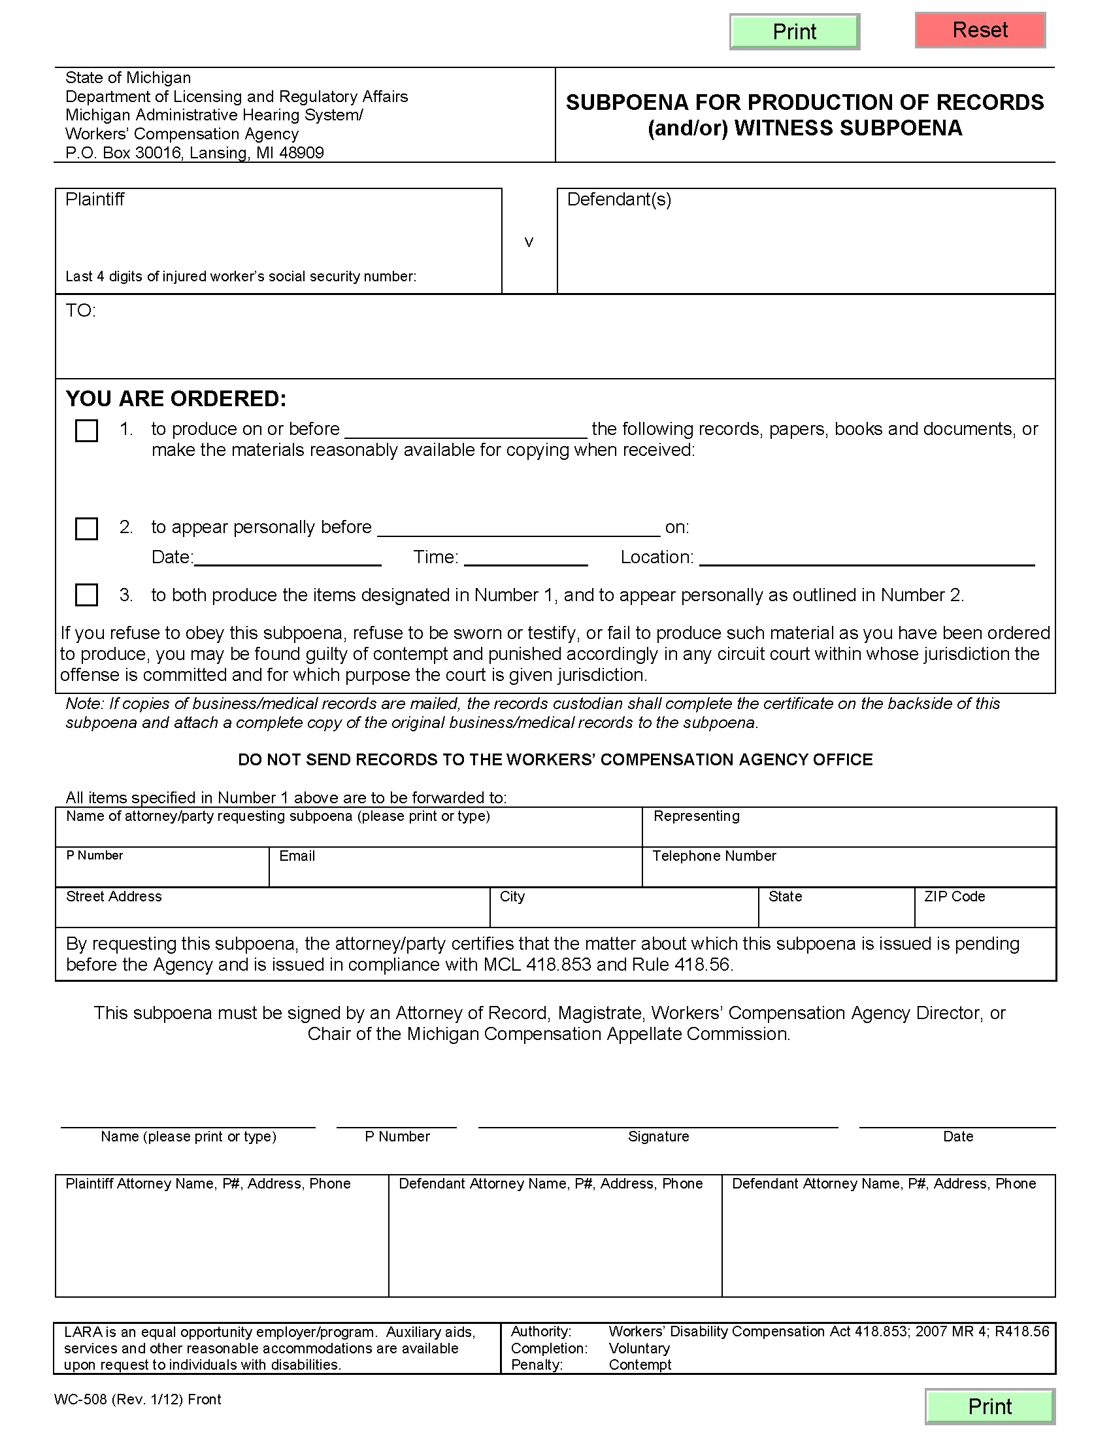
Batman

Gotham City

University of Michigan Hospital and Health Center Release of Information Unit
2901 Hubbard Street Room 2722
Ann Arbor, MI 48109-0000
John Doe c/o Axiom Requisition Copy Service

Axiom Requisition Copy Service @ 2869 Jolly Road
MI
48864
John Doe

Jack Zuk
Axiom Requisition Copy Service
2869 Jolly Rd
John Doe
03/15/2016
Order No. 01-29018-002

X
FROM 01/01/1979 TO PRESENT: Any and all MEDICAL RECORDS, including but not limited to patient history form(s), reports, etc. pertaining to Batman SSN: xxx-xx-5555, DOB: 01/01/1979.

Defendants

(123) 456-7890

Okemos

John Doe
123 East Main Street
Anywhere. MI 12345
(123) 456-7890
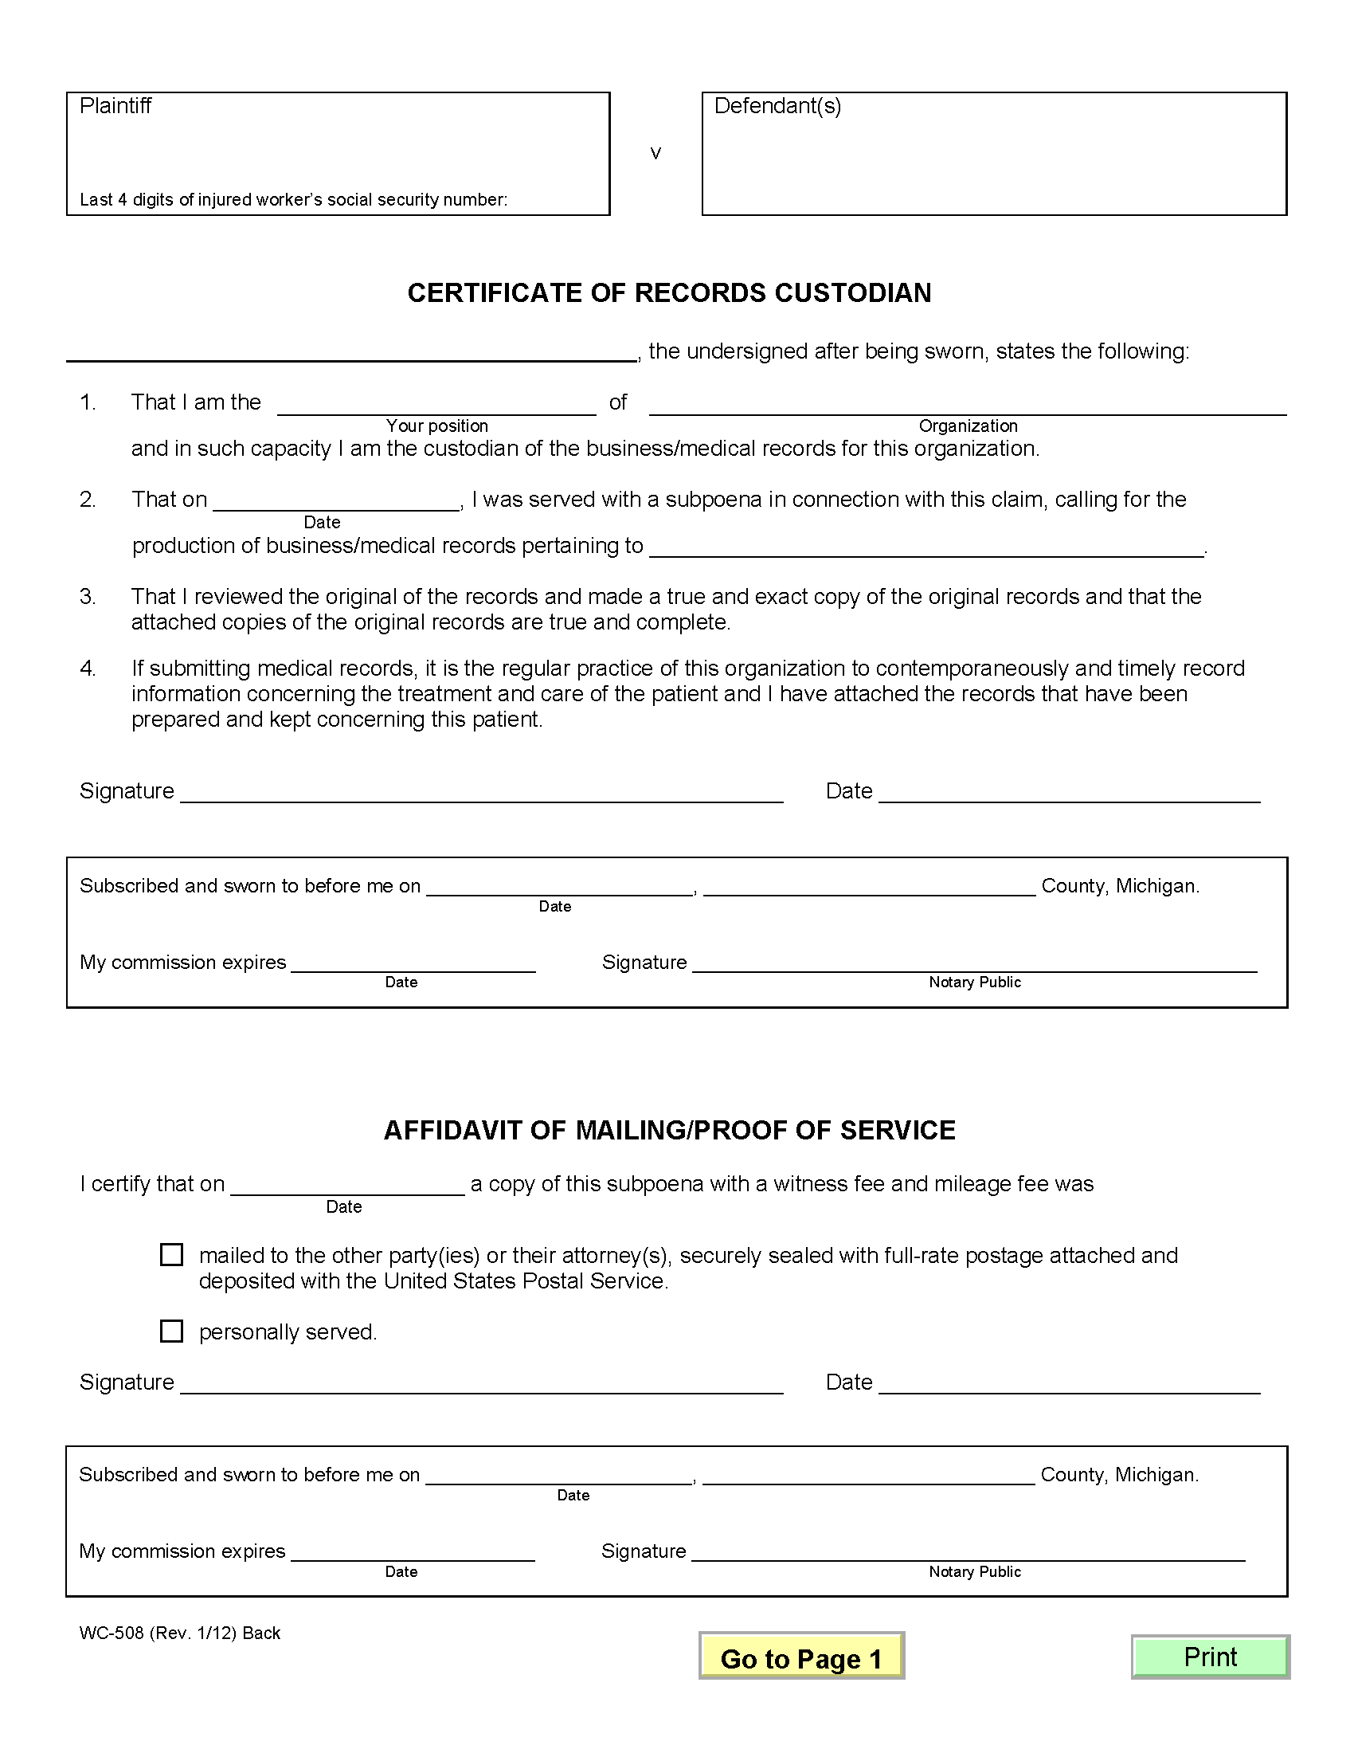

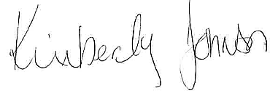
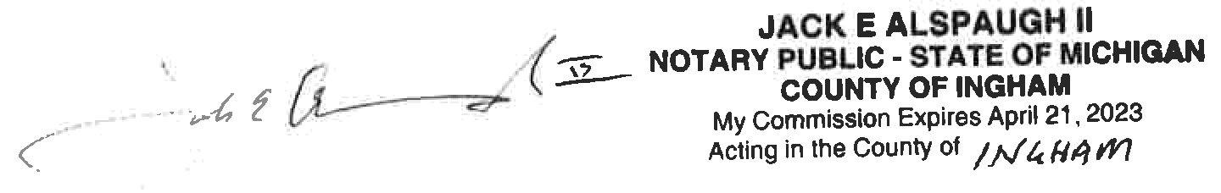
Order No. 01-29018-002
Gotham City

Batman

X

